**LIGHT WAVES**

**Reflections and Images**

**SAFETY WARNING**: DO NOT SHINE THE LASER AT ANYONE.

Be careful with the pins… Stick only into the cardboard.

Part A. Light through a vacuum

Does light travel through vacuum? Support your answer based on your readings and the NASA video you watched. __________________________________________________________

Part B. Reflection of Light

Look up regular and diffuse reflections. Explain why you can't see your reflection in a piece of paper. _______________________________________________________________________ _____________________________________________________________________________

____________________________________________________________________________________________________________________________________________________________

We already developed a relationship between angles of incidence and angles of reflection for water waves. Now we will see if the same one holds for light waves. Take a piece of cardboard, a piece of graph paper, plane mirror and two mirror clips to hold it up-right. Draw two perpendicular lines through the middle of the paper. Place it on the cardboard. Put the clips on each side of the mirror and stand it on one of the lines so that the other line is normal to the midpoint of the mirror. Measure an angle of 30° to the left of the normal line and draw that line. Shine the laser straight down the 30° line. Using an index card as a screen, mark where the laser light beam reflects to on the graph paper. (A trick that might help you is pointing the laser downward slightly so that the red dot hits right at the bottom of the screen.) Measure the angle between the normal and the reflected light ray, see drawing.

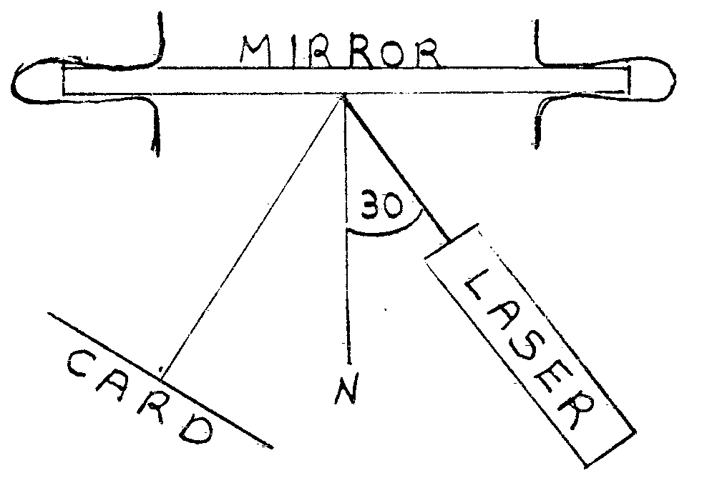

Angle of Incidence = 30°

Angle of Reflection = _________________.

Is this the same relationship you found for water waves? ______________

State the law of Reflection._______________________________________________________ ___________________________________________________________________________________________________________________________________________________________

Remove the laser and place a pin in the cardboard on the 30° line. Place a ruler anywhere on the paper so that you can sight along an edge of the ruler at the image of the pin, see drawing.

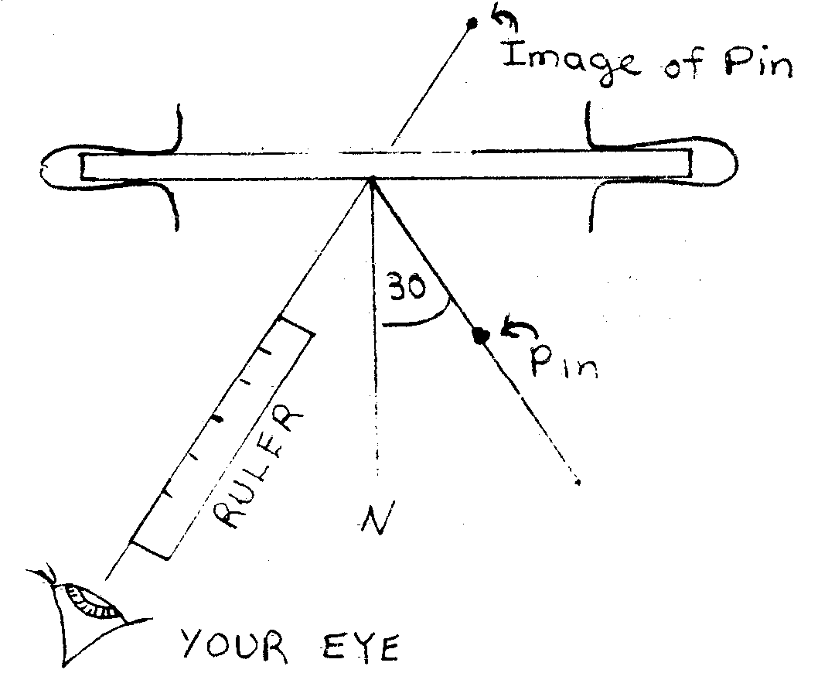

Draw a line along the ruler to mark that line of sight. Move the ruler to the left or right and again sight along it at the image of the pin. Mark that sight line, move the ruler once more and repeat the procedure. Remove the pin and mirror. Extend the sight lines to the point of intersection. All three lines should meet at the apparent location of the image. If they do not all meet at one point, redo the experiment more carefully.

Measure the distance from the pin to the mirror and from the image to the mirror.

Pin to mirror distance = _______________________

Image to mirror distance = _____________________

How do they compare? __________________________________________________________

_____________________________________________________________________________

____________________________________________________________________________________________________________________________________________________________

Since each sight line is a reflected ray of light, where each one meets the mirror, draw a normal to the mirror. The light that came to your eye followed a path from the pin to the mirror then back along the reflected ray to your eye. Mark the path of the incident light ray going from the pin to the point where you drew the normal, see drawing.

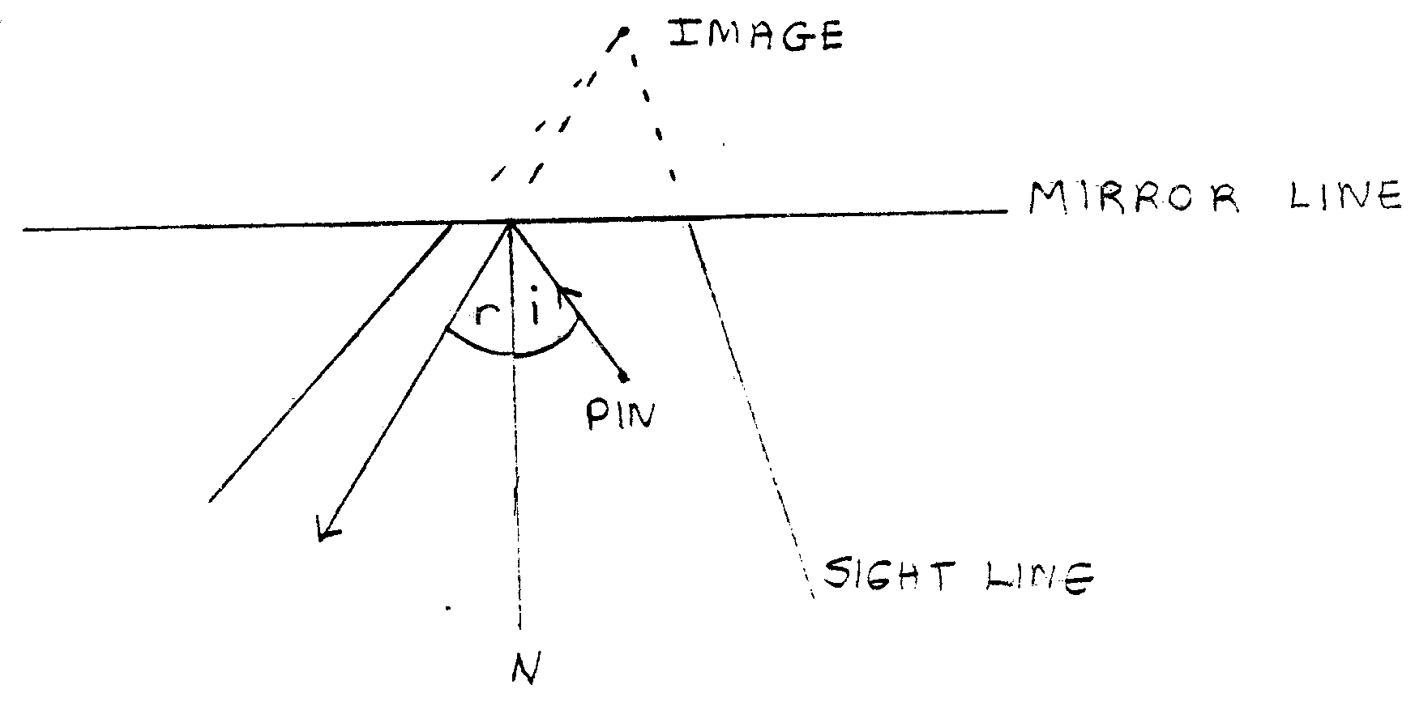

The line from the pin to the mirror is the incident ray and the angle it makes with the normal is the angle of incidence. Measure it and enter it in the next chart. The line from the mirror to where the ruler was is the reflected ray. The angle between the reflected ray and the normal is the angle of reflection. Measure and record that one too. Now repeat this procedure for the other incident and reflected rays and enter them in the table.

|  |  |
| --- | --- |
| Angle of Incidence | Angle of Reflection |
|  |  |
|  |  |
|  |  |

Have you once again confirmed the law of reflection? __________________________________

______________________________________________________________________________

Part C. Image Location

By sort of reversing what we did in Part B, it is possible to determine the location of the image of a given object. Begin with a clean sheet of graph paper. Draw a line to represent the mirror surface. Draw a dot to represent an object pin. With your ruler draw any line from the pin to the surface of the mirror. Where the line touches the mirror, draw a normal to the mirror. Measure the angle of incidence which is the angle between the normal and the incident ray that you drew. Now construct the reflected ray. Measure an identical angle on the other side of the normal and draw this ray going away from the mirror. Since this is the ray that corresponds to the one you lined up with the ruler in Part B, the ray would appear to come from the image of the pin. Extend this ray back "through" the surface of the mirror. Now repeat the entire process with another randomly selected incident ray. The point at which the backward extensions of the reflected rays cross is the location of the image. This process can be extended to whole objects instead of just points. For example, you could draw a triangle as your object. Do it, on another sheet of graph paper. Draw a line to represent the mirror. Then draw any triangle you choose to be in front of the mirror. Use the method you just learned above to locate the image of each corner of the triangle. When each corner image has been found, connect them and you will have the image of a triangle.

QUESTIONS

1. Find the point on your original triangle that is closest to the mirror. Is the image of this point also the closest to the mirror? ____________________________________
2. Does the point of the object that is farthest from the mirror produce an image point that is farthest from the mirror? __________
3. Stand the paper on edge so that the mirror line is vertical (up & down). Does the point that is the highest in the image come from the point that is the highest in the object? __________________
4. Is the same true for the lowest point in the image? ______________
5. Would it be fair to say that perspective has been maintained? _______
6. Is it fair to say that images in plane mirrors are reversed? Write a paragraph that states and defends a position on that.